

Cinema Management System
Lab 05
Date:
October 7, 2025
Submitted by:
Tayyaba Riaz – SP25-BCS-133-A
Submitted to:
Shahid Bhatti
Course Name/Code:
Object-Oriented Programming
CSC - 241

COMSATS University Islamabad,
Lahore
JAVA CLASS LISTINGS
- Seat.java defines a single seat with its unique ID, seat type (REGULAR, PREMIUM, VIP, or RECLINER), and availability status (true for available, false for booked). It provides getter and setter methods for accessing or modifying seat data. Each seat is created by the Screen class during screen initialization.
Key responsibilities: Store seat ID and type, track booking status, represent a single seat in the cinema layout.

- Screen.java represents a single screen in a cinema, containing a 2D array of Seat objects arranged in rows. It handles seat initialization, display, and booking logic. Each screen is also assigned a name (e.g., SCREEN-1).
Key features: Dynamically generates seats with increasing row sizes, assigns seat types based on row (front = Regular, back = VIP/Recliner), displays seat layout with availability indicators (A = available, NA = booked), allows seat booking through bookSeat() method, supports seat searching by type.
Purpose: Encapsulates all seat-related operations and layout handling within a single movie screen.
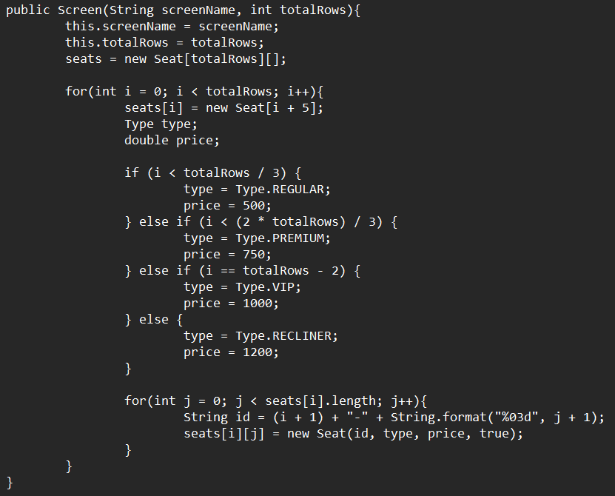
Excerpt 1: On constructor call, an object of array Seats is dynamically generated, with Seat Types assigned based on pre-defined constraints, instead of manual assignment.

- Cinema.java represents a single cinema building, containing multiple Screen objects and a list of movies playing on each screen. Each cinema has a name (e.g., CINEMA-1) and manages its screens independently.
Key responsibilities: Initialize multiple screens with assigned movies, display all screens and their currently playing movies, provide access to individual screens (getScreen(index)), support formatted display methods such as showScreens().
Purpose: Acts as a middle layer between CityCinema and Screen, managing all screens inside one cinema.
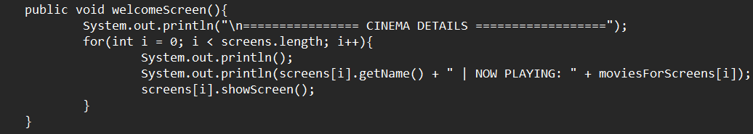
Excerpt 2: welcomeScreen() forms the bridge between screens and cinemas, displaying information in a user-friendly format.

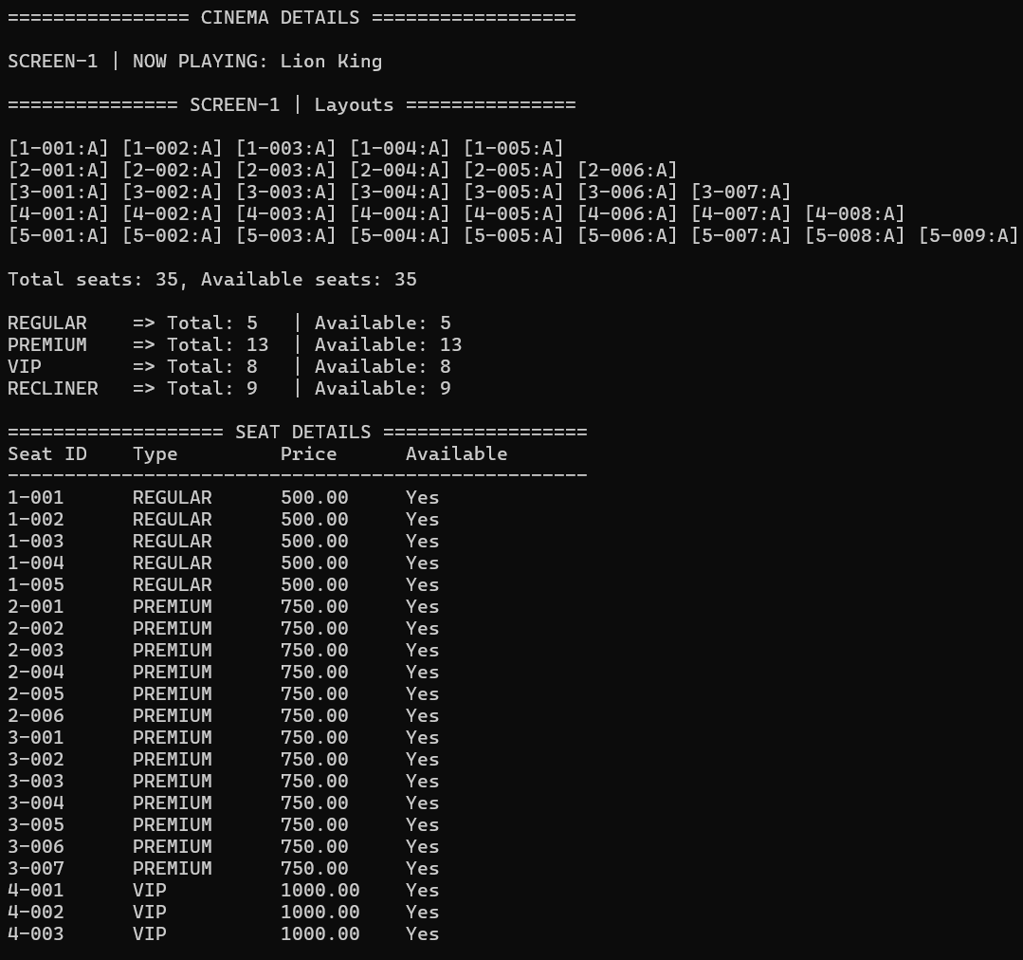
Excerpt 3: Sample output of welcomeScreen(), displaying screen details, and individual seating details.

- CityCinema.java represents a city-wide collection of cinemas, such as Karachi, Lahore, or Islamabad. This class manages multiple Cinema objects within a city and provides higher-level operations.
Key features: Initialize multiple cinemas within a city, display all cinemas and their screens (showAllCinemas()), search across cinemas for available VIP seats (findFirstAvailableVIPSeat()), find and return a specific cinema by name (findCinema(name)).
Purpose: Serves as a top-level container that manages all cinemas in one city and coordinates cross-cinema operations.
Excerpt 4: Cinema names are automatically assigned when constructor is called, along with number of screens.
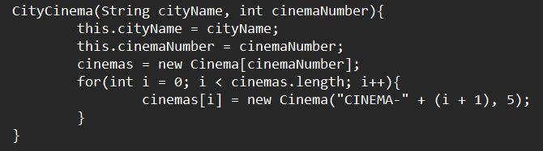
- SeatDemo.java is testing or demonstration class for the Seat and Screen functionalities. This class would typically create a few sample seats or a screen to demonstrate seat creation, seat booking and display and seat type assignments.
Purpose: Allows isolated testing of the lower-level classes (Seat and Screen) before integrating them into larger systems.
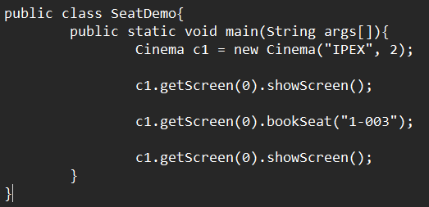
Excerpt 5: Individual seats and screens are easily accessible, along with ID-identified booking and cancelation. Changes are reflected and displayed using showScreen().

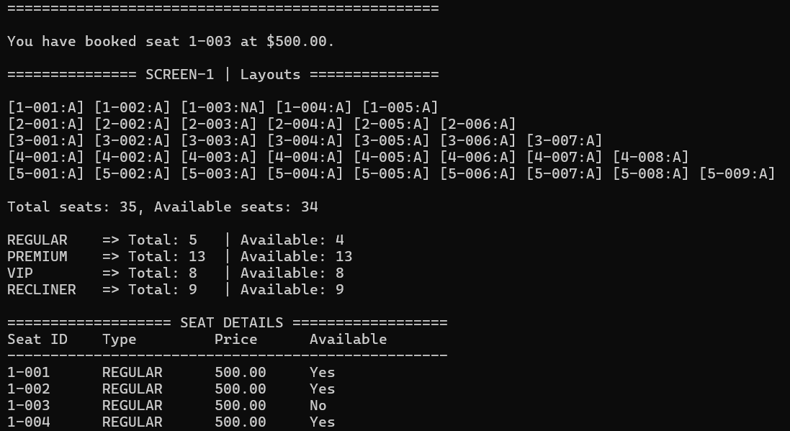
- CinemaDemo.java acts as the main driver class for the entire cinema management system. It demonstrates the interaction between all classes — from CityCinema down to Seat.
Example responsibilities: Create CityCinema objects for different cities (e.g., Karachi, Lahore, Islamabad), display all cinema layouts, book specific seats (e.g., bookSeat("3-007")), search for first available VIP seats across cinemas, find a specific cinema and view its screens.
Purpose: Serves as the main entry point for running and testing the full application.
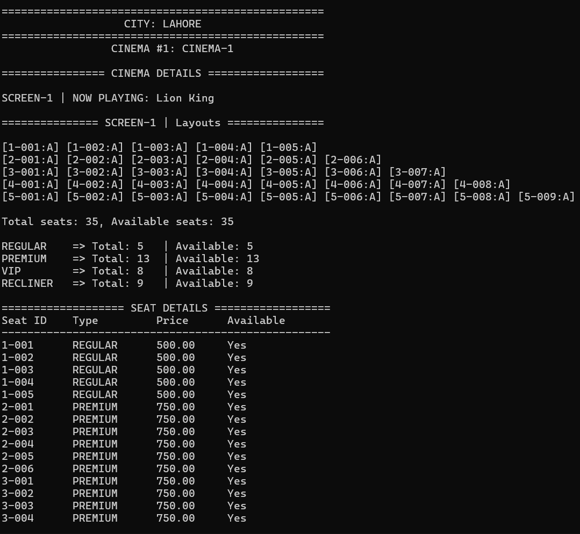
Excerpt 6: Full city report of all cinemas can be displayed using showAllCinemas(). It displays all cinemas, the screens, the seats layout and seat details.

